**Employee Application Documentation**

**Introduction**

Welcome to the Employee Application, a tool designed to manage employees and their skills efficiently.

**How to Use**

1. **Adding a New Employee**

- Upon landing on the system, locate and click on the "Add New Employee" button.

- A popup form will appear, prompting you to enter employee details.

- After filling in the details, click on "Add Skill" to input skills; they will be added to a list as you type.

- Click "Save" to store the employee record with the added skills.

Page where you will be capturing the info

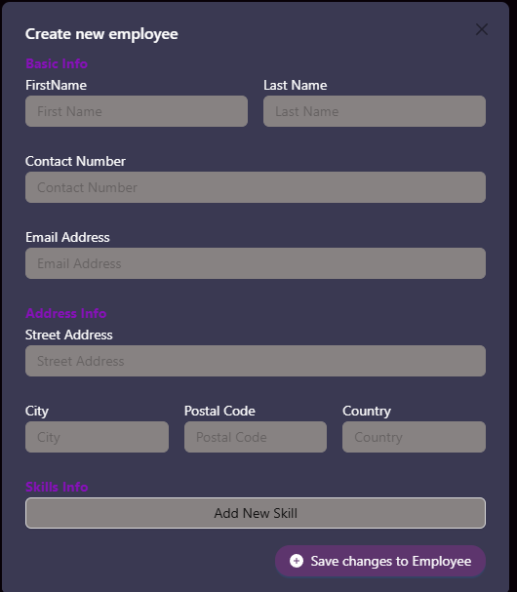

2. **Viewing and Editing Employee Records**

- To view details of an employee record, click on the respective item in the list.

- A modal popup will display the employee details.

- From the modal, you can edit existing skills or delete them as needed.

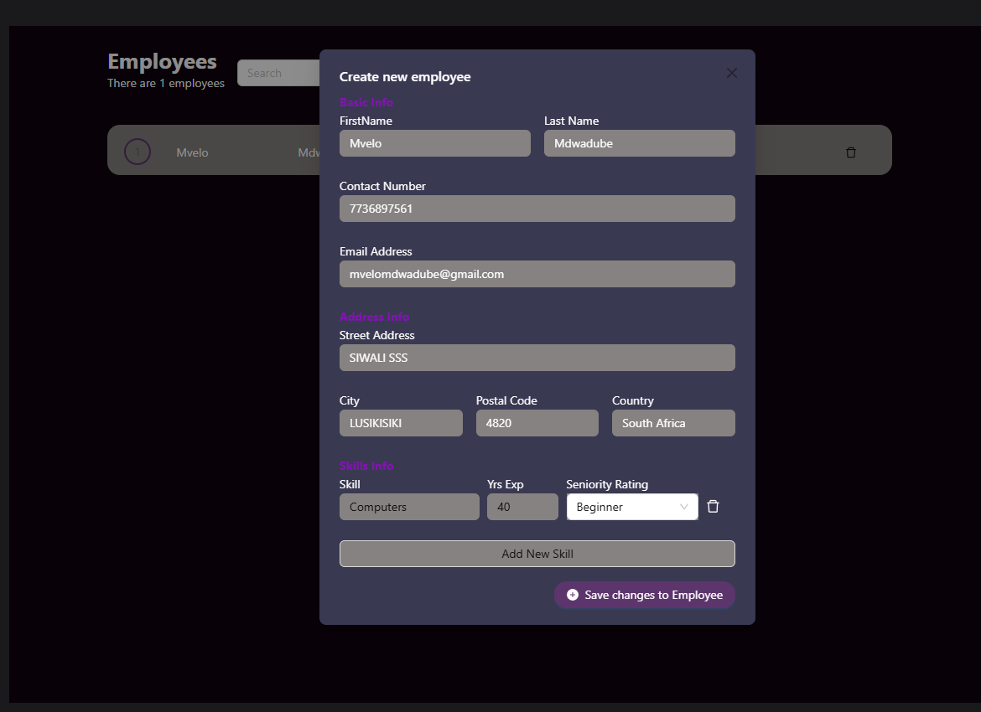

3. Deleting an Employee Record

- Each item in the employee list has a "Delete" button at the end.

- Click on this button to remove the employee record permanently.

4. Filtering Employee Records:

- Search Box: Type in the search box to filter employees by name, last name, or surname.

- Dropdown Filter: Click on the dropdown menu to select filter options (e.g., department, position).

- Choose the desired filter option and enter the filter criteria.

- Click on "Apply" to apply the filter or "Clear" to reset and view all records.

Conclusion

With the Employee Application, managing employee information and skills is streamlined and intuitive. Enjoy using our application to enhance your workforce management capabilities!